Cover page

Part 1. Preamble
This report describes work that I have done in my final year project, developing a low power communication system for long distance data transmission.

This main report contains a copy of the approved Project Proposal (Section 1) and technical documentation (Part 4 of the report). The latter provides more detail on the software that was used in the experiments, including program listings, a user guide and circuit designs. This section appears on the CD or DVD that accompanies this report.
This document has been edited by a knowledgeable person. By submitting this document in its present form, I declare that this is the written material that I wish to be examined on.
My language editor was Ms. Marélette van Dalen.

Language editor signature Date

I, R.M. Lombard understand what plagiarism is and have carefully studied the plagiarism policy of the University. I hereby declare that all the work described in this report is my own, except where explicitly indicated otherwise. Although I may have discussed the design and investigation with my study leader, fellow students or consulted various books, articles or the internet, the design/investigative work is my own. I have mastered the design and I have made all the required calculations in my lab book (and/or they are reflected in this report) to authenticate this. I am not presenting a complete solution of someone else. Wherever I have used information from other sources, I have given credit by proper and complete referencing of the source material so that it can be clearly discerned what is my own work and what was quoted from other sources. I acknowledge that failure to comply with the instructions regarding referencing will be regarded as plagiarism. If there is any doubt about the authenticity of my work, I am willing to attend an oral ancillary examination/evaluation about the work.

I certify that the Project Proposal appearing as the Introduction section of the report is a verbatim copy of the approved Project Proposal.

R.M. Lombard Date

Table of Contents
List of Abbreviations iv
List of Definitions v
Part 2. Summary Section vi
Part 3. Main Report viii
1. Problem Proposal 1
1.1. Problem statement 1
1.2. User requirement statement 2
1.3. Functional analysis 3
1.4. System specifications 6
1.5. Deliverables 8
1.6. References 9
2. Literature Study 10
3. Design and implementation 14
3.1. Approach 14
3.2. Detailed design and implementation 14
3.3. Design Summary 14
4. Results 15
4.1. Summary of results achieved 15
4.2. Qualification tests 15
4.3. Results and observations 15
5. Discussion 16
5.1. Interpretation of results 16
5.2. Aspects to be improved 16
5.3. Strong points 16
5.4. Under which circumstances will the current system fail? 16
5.5. Design ergonomics 16
5.6. Health and safety aspects of the design 16
5.7. Social and legal impact and benefits of the design 16
5.8. Environmental impact and benefits of the design 16
6. Conclusion 17
6.1. Summary of the work 17
6.2. Summary of the observations and findings 17
6.3. Suggestions for future work 17
7. References 18
Part 4. Technical documentation 20

List of Abbreviations
AI
Artificial Insemination, 11
NI
Natural Insemination, 11

List of Definitions

B
butting
When two animals To hit or push against with the head or horns., 10
E
economical component
A component of measure when calculating the impact thereof on the financial success of the given subject, 10
estrous
A regularly recurrent state of sexual excitability during which the female of most mammals will accept the male and is capable of conceiving, 1, 2, 3, 4, 6, 7, 9, 10, 11, 13

Part 2. Summary Section

Cattle Monitoring
  - R.M. Lombard, Prof. B.T.J Maharaj

Abstract

I. Problem identification

II. Methods

III. Results

IV. Discussion

V. Conclusion

References

Part 3. Main Report

Problem Proposal

Problem statement
Motivation. Currently South Africans consume 700 000 tons of red meat per annum, and it is said to increase with 25% by 2020 [1]. The national beef herd, including the informal sector, is estimated at 13-14 million head. South Africa currently produces 85% of its meat requirement [2]. Due to low calving percentages and high mortality rates, the full demand can't be met. The problems are caused by poor cattle management, incorrect genetic mixture of cattle and using artificial insemination when the cow has low estrous levels. It is estimated that if calving percentages could increase by 35%, herd composition improved and carcass mass increased, the national beef supply could increase and sustain the nation without importing meat internationally [2]. This project will address the problem of cattle management by improving cattle monitoring and aiding in the detection of estrous behaviour to improve operation and efficiency, by genetics.

Context. Research has been conducted to determine if estrous behaviour can be determined by use of proximity sensors. The research showed an increase in interaction between cattle when estrous levels increased [3]. Some complications arise when cows go into calving [4], especially in heifers (a young cow before she has had her first calf). These complications can easily be countered by human intervention. This is not always possible as farmers are not always present. The project will extend on the research in behavioural patterns in determining estrous and social behaviour in cattle, by means of proximity sensing. It will also aid the farmers in determining a cow's health, especially during calving periods, to react before complications arise [5].

Technical challenge. The engineering challenge is to design and develop a device capable of (i) active real-time wildlife monitoring; (ii) recording proximity between animals; (iii) recording movement of an animal; (iv) wireless communication to a remote server; (v) being accessible from anywhere in the world; (vi) able to determine social and estrous behavioural patterns; (vii) to aid in managerial decisions, such as the use of artificial insemination, for each individual animal. The device will be piloted by cattle and can later be modified to support other farm animals and wildlife.

Limitations. The devices are required to be mobile, lightweight and comfortable for the animal to wear. The devices will have limitations in power consumption, as battery power will be used. Costs are also considered as a project constraint, as devices used and cost of the complete system should be kept as low as possible, with minimal loss in functionality. The device should operate independently for several days, therefore low power hardware will be required. It should be determined if solar power could be used to increase the lifetime of the devices, keeping the cost within budget. Ethical clearance will have to be gained for the electronic devices to be placed on the cattle. The challenge of working with live cattle will also have to be considered. Co-operation from the Faculty of Veterinary Science will be required to work with the cattle at Onderstepoort [6]. The use of live cattle will limit the number of testing opportunities.

User requirement statement

Design Part of the Project
Task breakdown
Successful completion of the project will include the following tasks.
- A working prototype capable of detecting proximity between other devices, should be designed.
- A working prototype capable of detecting sudden changes in movement of an animal, should be designed.
- A mountable collar, capable of housing the hardware, should be designed.
- It should be investigated how motion and proximity sensing can be determined and data collected.
- Sufficient power supply should be investigated and a sufficient power source should be determined.
- A server should be set up, capable of processing the data and communicating with the devices remotely.
- A database needs to be designed, able to efficiently store and query the data received from the devices.
- Software should be designed capable of determining social patterns in the herd.
- Software capable in determining estrous behaviour within the herd should be designed and implemented.
- A mesh network should be implemented using XBee technology, capable of device and server communications.
- A user-friendly interface needs to be designed and implemented for easy access to the logged data.
- A notification system should be designed and developed, capable of notify the user remotely of estrous behaviour in individual animals.
Mission requirements of the product
Specific details of the system mission requirements are given below.
- The device should be mountable to each animal in a safe and non-discomforting way.
- The device should be robust and rigid enough to stay attached to the animal through rough motion, and be able to keep the internal hardware safe.
- The size of the device should not exceed 150mmx120mmx100mm, weighing less than 500 grams.
- The device should be powered by batteries, have a reasonable lifetime and recharge capabilities.
- A set of devices should be able to determine proximity between each other.
- A set of devices within close proximity should be able to recognise each other, and translate the data to the server.
- A device should be able to detect sudden changes in movement of each animal.
- Movement and proximity data should be logged on the device and communicated to the server.
- The server and database should be able to handle high volumes of data and must be scalable.
- Software running on the server should be able to detect estrous behaviour in each animal.
- The data should be easily communicated to, and be understandable by the average user.
- The server should give notifications and recommendations to the user in real-time.

Investigative Part of the Project
Research questions
The investigative part of the project is to determine if signal strength between wireless devices can be used to accurately determine the proximity of the devices to each other, and if not, find an alternative solution. Furthermore, battery technology and power requirements will be investigated, including the feasibility of solar power. It will also be investigated how proximity between animals, movement within social groups within the herd and sudden changes in movement determines estrous behaviour in animals. The question of interference between the device and the animal in close proximity will need to be investigated as it will affect the accuracy and reliability of the system.

Functional analysis
The overall system will be broken down into three functional areas as given in Figure 1 to Figure 3.
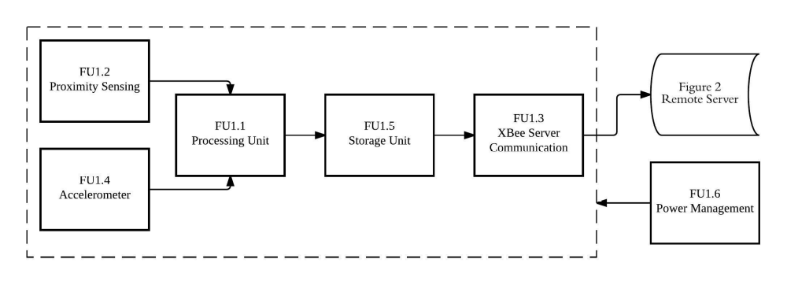
Figure 1.
Functional diagram of devices worn by cattle.
The device referred to in Figure 1 is the physical device that will be mounted on the animals, and should be able log sensory data and communicate with a remote server. The processing unit (FU1.1) will receive data from units FU1.2 and FU1.4, which will then be processed to determine proximity between devices and sudden changes in movement. This data will be communicated to the server via FU1.3. For communication to the server (Figure 2), XBee devices connected in a ZigBee Mesh Network will be used. The proximity sensing unit (FU1.2) will determine if neighbouring devices are within close proximity, 1-2 meters of each other, inform the processing unit (FU1.1), and a contact event will be logged on the storage unit (FU1.5) and communicated to the server. The logged data will comprise of both unique identifiers of each device and the date and time of the event. The storage unit (FU1.5) will log data before it is sent to the server, and will serve as a local data backup. FU1.4 will comprise of an accelerometer to determine the movement data of the animals. This will provide data such as sudden changes in orientation or movement and determine whether the animal is standing or lying down. This data will be logged in terms of the directional axis of the sudden change in movement, together with the device's unique identifier. Finally, the power management unit (FU1.6) will strive to provide uninterrupted power to the device. The power management unit will comprise of a rechargeable battery and recharging circuitry coupled with a small solar panel that will be mounted on the animal. This will form part of the investigative study, see 1.2.2.
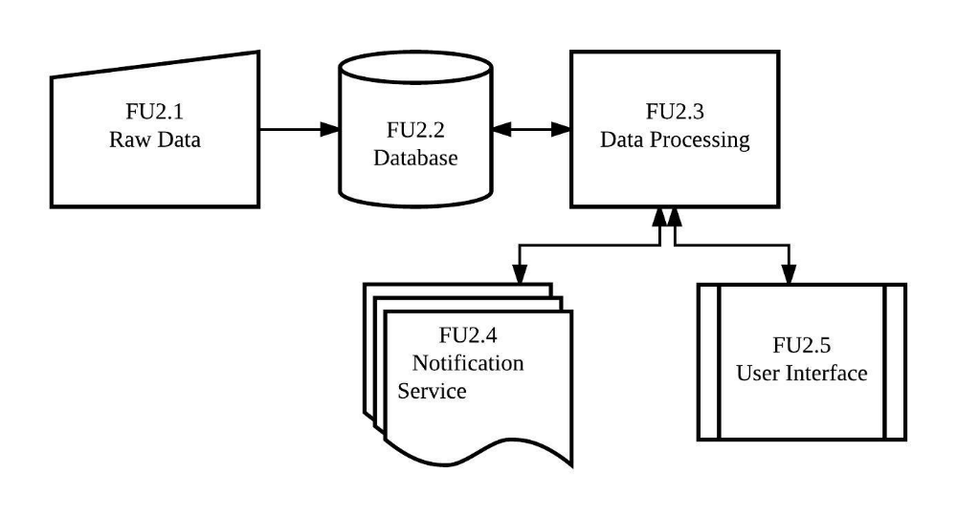
Figure 2.
Functional diagram of the remote server.
The remote server is referred to as a remote processing unit, capable of receiving data from the devices in Figure 1, and be able to process the data to give the user critical information about the animals. The remote server will be a web-server running the designed software to process and view the data. Raw data (FU2.1) will be received from the devices, after which it will be stored in a database (FU2.2). The database will be designed using SQL and will be scalable to handle large amounts of data. The software will determine social patterns within the herd. It will determine estrous behaviour (as researched and in collaboration with the Faculty of Veterinary Science of Onderstepoort) in individual animals, by processing (FU2.3) the raw proximity and movement data received from the devices in Figure 1. The processed data will be displayed on the User Interface (FU2.5). Along with the database running on the server, there will also be a background service (FU2.4). This service will poll the database at a predetermined time to determine anomalies in the data. Once an anomaly is found, such as high contact between cattle, contact between cattle in different social groups or sudden changes in movement, the service will send a notification (FU2.6) to the user, advising them to investigate. A user interface (FU2.5) will be designed using web interfacing software. This will be web pages, accessible across the world, where the user can query reports and data based on individual animals, social groupings and estrous behaviour. The reports will give the user crucial information in managing the cattle advising the user whether to use artificial insemination and information regarding the genetics of the given animal. The reports will be readable and understandable by users with little or no agricultural experience.

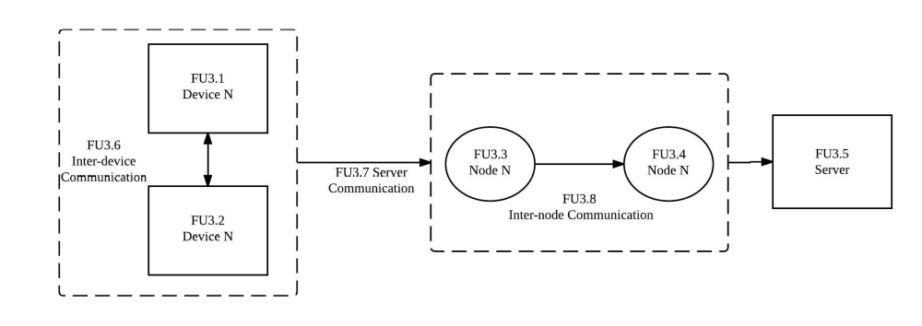
Figure 3.
Functional diagram of the network.
Finally a wireless network will be designed and built using devices such as XBee, utilising a ZigBee Mesh Network design. The network, shown in Figure 3, is defined as the communication between the devices, nodes and the server to send and receive data. Inter-device communication (FU3.6) will occur when the devices are within close proximity of each other, where after the device unique identification field will be transmitted and logged between devices FU3.1 and FU3.2. An N Number of devices can be connected. Server communication (FU3.7) will occur when the device communicates to send logged data to the server. This will be accomplished by communication between the device (FU3.1) and its closest node (FU3.3). After communication to the closest node, inter-node communication (FU3.8) will occur. This will allow the project to be scalable to greater areas, or areas with higher interferences that lead to lower signal strength and shorter communication distance. The final node (FU3.4) will communicate directly with the server. Data packets will be sent between devices and nodes, comprising of the data gather by the device.

The mountable collar will comprise of a housing unit, collar band, and recharging hardware. The housing unit will be a robust durable plastic housing, capable of housing the required hardware. It will be lightweight, yet tough enough to withstand rough use of the animals scratching and bumping it against the environment. The housing should in no way obstruct the animal’s movement. The collar band will be a durable material band that would not injure the animal, and be comfortable. Finally a small solar panel will be mounted on the collar band. The solar panel should not obscure the animal’s movement. All external wires will run through the collar band, to ensure they are not exposed and to keep the wiring safe along with keeping the animal safe.

System specifications

Mission-Critical System Specifications
Detailed mission-critical specifications, as per Figure 1 to Figure 3, are given in Table 1 below.

SPECIFICATION (IN MEASURABLE TERMS) | ORIGIN OR MOTIVATION OF THIS  SPECIFICATION | SYSTEM COMPLIANCE TEST
The device (Figure 1) should log the ID of the neighbouring device, its own ID and the proximity measurement taken. | This specification is will be the driving force of the project. It is important not only to know the animal was in a contact event, but also the animal it was in contact with. | Two devices will be brought within proximity with each other, and the system will be checked. Two contact events should be logged, both containing the opposite device ID together with its own.
The software running on the server (Figure 2) should be able to determine social groups within the herd with 85% accuracy. | Social behaviour is key to determine estrous behaviour in herds. Estrous behaviour include moving from the animal's regular social group to another. | Social groups in a herd will be determined by guidance form the Veterinary Science department at Onderstepoort, and devices will be mounted on the animals. The results from the devices and server will be compared with the live result.
The software should be able to determine the animal’s movement within social groups. It should detect with 80% accuracy when an animal moves from one social group to another. | The movement within social groups are used to determine estrous behaviour within the herd. | Once social groups are determined, the animal’s social movement will be monitored, both physically and with the device, and results will be compared.
The Proximity Sensing Module (FU1.2) should log data when devices are within 2 meters of each other (line of sight), with 85% accuracy. | Proximity between cattle are critical in determining contact situations. The contact situations in turn determine behavioural patterns. | Two devices will be placed within 2 meters of each other, and the proximity will be calculated with the available data. This will be repeated 25 times, and the accuracy will be confirmed.
The Proximity Sensing Module (FU1.2) should determine the distance between devices accurately within 50 cm (line of sight). | The specification was chosen by taking in consideration the effects of interference in given environments. | Two devices will be placed within 2 meters of each other, and the proximity will be calculated with the available data. The software will respond with a digital calculation of the distance, and be compared.
Server Communication (FU3.7) should cover an area of minimum 80 hectares (line of sight). | Minimal nodes should be used to keep costs as low as possible, without compromising connectivity. | The nodes and devices will be set up in an available area, Onderstepoort, and connectivity tests will be conducted to determine the effective range of communication.
The device should not exceed 150mmx120mmx100mm | Cattle tend to rub themselves against trees. Limiting the size of the package will reduce to the possibility of damage to the device. | The package size will be measured and it will be determined if it complies with the limitations.
The device should be mountable on the animal, without causing discomfort. | The devices should record the animal's movements within the group. The device mounted on the animal should not cause distress. | The end product will be mounted on a live animal and it will be studied for a week. If the animal does not show signs of discomfort the specification shall be met.
Table 1.
Mission-Critical System Specifications.

Functional Unit Specifications
Detailed functional unit specifications, as per Figure 1 to Figure 3, are given in Table 2 below.
SPECIFICATION (IN MEASURABLE TERMS) | ORIGIN OR MOTIVATION OF THIS SPECIFICATION
The Processing Unit (FU1.1) should have enough communication and I/O ports to connect all the required peripherals. | Without the processing unit the sensory units would prove invaluable. Enough ports are required to connect the required peripherals.
XBee server communication (FU1.3) should be connected using a ZigBee Mesh Network design. | A mesh network will reduce communication traffic and also aid in reaching the range requirement.
The XBee modules (FU1.3) should have cyclic sleep functionality to reduce power usage, and use less than 70 mA average current | Since the device will be battery powered, using the minimal amount of power will be essential.
More than 75% of data packets should be received from the devices (FU1.3) given normal operating conditions. | A 75% efficiency will be enough to determine patterns in social and estrous behaviour accurately.
The Accelerometer (FU1.4) should be able to detect sudden changes in movement in 3 axes. | Sudden changes in movement could be used to identify social and estrous behaviour.
The Storage Unit (FU1.5) should be able to log up to 2 GB of data. | If communications are down or if cattle move out of range, data still has to be logged.
The Power Supply (FU1.6) should be able to be recharged using solar power. | Batteries can be removed and recharged, but in large scale operation it would prove too costly.
The Power Supply (FU1.6) should have a minimal operation time of 1 month, in normal conditions (Devices operating in clean line of sight conditions). | When artificially inseminated it will be able to change the batteries within the process. 1 Month lifetime would be acceptable.
The server (Figure 2) should be remotely accessible over a standard TCP/IP network. | The user should be able to check cattle remotely, since not all small-scale farmers are full-time farmers.
The Notification Service (FU2.4) should notify the user within 10 minutes of anomaly detection. | 10 Minutes after an anomaly is an acceptable response time, based on feedback.
The User Interface (FU2.5) should be web-based and easily accessible by means of a standard home computer and Internet connection. | Farmers are not necessarily computer literate or used to working on computer interfaces. The user interface should therefore be easy to use and understandable irrelevant the user's computer competency.
The network (Figure 3) should perform in real-time and data transfer should occur with minimal latency. | Data should almost instantaneously be available on the server, to give the user the sense of engagement.
The database (FU2.2) should be scalable, less than 5 % increase in processing time per 1 million data records. | Data should almost instantaneously be available on the server, to give the user the sense of engagement.
Table 2.
Specifications of Functional Units.

Deliverables

Technical Deliverables
DELIVERABLE | DESIGNED AND IMPLEMENTED BY STUDENT | OFF-THE-SHELF
Hardware required to determine proximity between devices. |  | X
Software required to determine proximity from hardware readings between neighbouring devices. | X
Hardware required to communicate to remote server |  | X
Hardware required to determine movement |  | X
Hardware required to process the sensor data |  | X
Hardware required to store data on devices |  | X
Hardware design, including the above specified modules that need to be selected and incorporated into the design. | X
A PCB design to incorporate hardware design above. | X
Software required to measure movement. | X
Software capable of determining social behaviour within the herd. | X
Software required to determine movement patterns. | X
Device-Server communication | X
Database design from first principles | X
Remote Server running required software. |  | X
Notification system and user interface. | X
Four mountable devices to use for testing and demonstration purposes. | X
Two Node devices to use for testing and demonstration purposes. | X
Table 3.
Technical Deliverables.

Demonstration at the Examination
The following will be demonstrated at the examination:
- Four device will be mounted on live animals that will log data prior to the demonstration.
- The live data will be shown running on the server, by use of the User Interface.
- Reports will be queried from the live server, and the results explained and shown.
- A basic demonstration of how the device function will be shown.
- Two devices will be at hand, connected with a node to a local server.
- The devices will be placed out of proximity range of each other, and moved into and out of proximity.
- The data logged from the devices will be shown on the local server.
- Movement anomalies will be introduced by extensively moving the device.
- The data logged from the devices will be shown on the server, along with the notification received by the user.
- The communication range will be shown by referring to results taken prior to the demonstration.
- The scalability of the database will be shown by data extrapolated from experiments done prior to demonstration.
- The evidence of power requirements as reflected in the investigation on the relevant matter will be shown and discussed.

References

[1] SouthAfrica.info. (5 March 2015) Southafrica.info. [last accessed 5 March 2015]. [Online].
Available:http://www.southafrica.info/business/economy/sectors/542547.htm

[2] J. de Jong. (5 March 2015) Farmers weekly. [Last accessed 5 March 2015]. [Online].
Available:http://www.farmersweekly.co.za/article.aspx?id=44228&h=South-Africa’s
beef-industry:-what-does-the-future-hold.

[3] C. O’Neill, G. Bishop-Hurley, P. Williams, D. Reid, and D. Swain, “Using UHF proximity
loggers to quantify male-female interactions: A scoping study of estrous activity in cattle,”
Animal Reproduction Science, vol. 151, pp. 1–8, 2014.

[4] W. J. Grobler. (5 March 2015) Protea animal clinic. [Last accessed 5 March 2015]. [Online].
Available: http://www.proteaanimalclinic.co.za/Siektes/calving1.htm

[5] L. M. Schwalbach, I. B. Groenewald, and C. B. Marfo, “A survey of small-scale cattle
farming system in the North West Province of South Africa,” South African Journal of
Animal Science, vol. 31, no. 3, pp. 200–204, 2001.

[6] Onderstepoort location: M35 Onderstepoort Pretoria 0110, 25 February 2015, [Last
accessed 5 March 2015]. [Online]. Available: http://www.up.ac.za/faculty-of-veterinary
-science.

Literature Study

Analysis of cattle behaviour has become a crucial part of any successful livestock farmer. When looking at cattle and wildlife farming, it is especially important to be able to determine estrous behaviour in female animals as it is an economical component. When a female animal shows signs of estrous behaviour, reproductive methods such as artificial insemination (AI) are more likely to give successful results. The increase in successful reproduction increases calving percentages leading to greater economical yields [1].

Esselmont et al. [2] proposed an assortment of behavioural components in determining estrous behaviour, and how these components change when a cow reaches estrous. The study quantified these components and found that all components were shown even when the cow was not asserting estrous behaviour, albeit low or very low frequencies. Once the cow was nearing estrous, these component frequencies increased.

Similarly, in studies conducted by Solano et al. [3] and Sveberg et al. [4] it was shown that components of behaviour in cattle such as: licking, butting, attempts to mount, mounting and movement in social groups, were indicators of estrous behaviour. Both studies were conducted using visual observers over periods of time, to count and record the physical estrous indicators, or interactions, and comparing the results with veterinary evaluations of cattle. The results showed an increase in interactions between the cattle when the cows were in estrous.

From these studies it can be concluded that these behavioural components or estrous indicators can be quantified as an action where two animals are within proximity between each other for a period of time, further referred to as an interaction. When the number of interactions and length of interactions increase, it can be concluded that the female animal shows estrous behaviour.

Proximity loggers have long been in use to determine and quantify intra- and interspecies interactions. Proximity loggers collect interaction histories, over a specified period of time, and allow researchers to retrieve the data for analysis. The analysis of the data in turn produces social and behavioural patterns within the sampled animal community, which can be used to determine estrous behaviour.

In 2012, Drewe et al. [5] conducted a study to determine the performance of proximity loggers used in a field based test compared to that of a laboratory test. For the field test proximity loggers were mounted on cattle by means of a collar, with data recording over a period of 15 months (although not all collars collected data over the whole time period due to the loggers reaching maximum capacity of 16 384 records). The laboratory test validated the reach and accuracy of the loggers, both before and after the 15 month time period. It was shown that due to decreases in battery life, a moderate reduction in initiation and termination distances and a widening in range detection occurred. To validate the field test, visual observations of interactions were taken by an observer over a two day period. The cattle was observed for 30 minutes from a distance of approximately 20 meters. Cattle were considered to be interacting when they were within one head's width of another animal. The results showed the loggers logged 129 out of the 179 (72%, range: 50% to 94%) interactions observed by the observer during the six hours of visual observations.

In a study conducted by Walrath et al. [6] in 2011, White-Tailed Deer were captured and held in an observation field. A proximity logger was mounted on the deer with a collar. Two pairs of deer were placed in the observation field, and an observer would count interactions between the deer. A total of 72 hours of observer data and 432 hours of proximity logger data was taken. To ensure objectivity and the deer to continue previous behaviours, the observer entered the field 15 minutes before the recording was initiated. Interactions were defined as occurring when the deer were within 1 meter of each other (approximately the body length of the deer). As a result the observer recorder 500 interactions, whereas the loggers recorded 774 interactions. The efficiency of the loggers were found to be 64% versus the 34% of the visual observer.

From the studies above, it can be concluded that proximity loggers are able to accurately record interactions between animals, and in some cases better than visual observers. The loggers are also capable of recording data for extended periods of time, which is not possible with visual observers. It can also be concluded that although proximity loggers are efficient, battery life and environmental factors has an influence on the accuracy of the data recorded.

As a confirmation of the studies conducted by Esselmont et al. [2], Solano et al. [3] and Sveberg et al. [4]; O'Neill et al. [7] conducted a study in 2014 to determine if using proximity loggers to quantify male-female interactions would provide information regarding estrous behaviour in cattle. The study found 2-3 times more interactions for estrous cows than non-estrous cows, with the interactions lasting 3-5 times longer. The study concluded that proximity loggers are capable of recording inter-animal interactions with both wildlife and livestock.

From the relevant studies it is clear that proximity loggers are a helpful tool that can be used in both livestock and wildlife management, although it is presented with a few shortcomings. In all cases the loggers were mounted on the animals, left for a period of time, and then removed. Only after the devices were removed could the data be analysed. In some cases the loggers ran out of memory, and were not able to record data until it was removed and wiped. Decreasing battery lifetime reduced the efficiency of the loggers.

As a supplement to the list of behavioural components, a study to determine estrous behaviour in cattle based on walking activity was conducted by Silper et al. [8] in 2014. The study monitored cattle by using accelerometers and video observations to better understand the behavioural expression of estrous. The number of steps taken by the cattle was monitored. It was reported around 100 steps per 8 hours as a baseline and 400 steps per 8 hours of estrous. Thus it could be concluded that an increase in walking (steps taken) can be seen as an indication of estrous behaviour in cattle.

Chanvallon et al. did a comparison study [9] between using a pedometer (accelerometer aided by software to determine steps taken) and two activity meters (a Heatime-RuminAct and a HeatPhone), to evaluate their relative performance. The data was collect on the devices over a given period of time, and transmitted to a central database using radio telemetry. The reliability of each device was defined by their sensitivity to correctly detect estrous behaviour and the accuracy in positive detection. The results showed higher sensitivity in the pedometer (71% versus 62%) to detect estrous behaviour, but a lower accuracy of positive detection (71% versus 84%). Although the pedometer gave less accurate results, the results were still able to show conclusively that estrous behaviour can be detected by using a pedometer.

Reproductive efficiency is an important determinant of profitable cattle breeding operations, as well as the success of assisted reproductive techniques in wildlife conservation programs. The use of artificial insemination (AI) can greatly yield higher pregnancy rates in a livestock farmer’s cattle. From a managerial perspective, it also allows the farmer to more accurately determine the year’s expected cost and profit, since it is possible to know when a cow is going to be pregnant. AI also increases the likelihood for a cow to become pregnant versus natural insemination (NI), as the farmer can say with certainty that a cow has received semen.

When artificially inseminating cows, one of two techniques can be used, Fixed-Time Artificial Insemination (FTAI) or AI after estrous detection (EDAI). FTAI is used after successful implementation of an ovulation synchronization protocol. All cows are then artificial inseminated on the same predetermined time. Alternatively EDAI relies on estrous detection, and once a cow is found to show estrous behaviour, she is artificially inseminated. Both of these techniques have their respective advantages and disadvantages. In a comparative study by Edwards et al. [10], it was shown that using EDAI, the cost per calf was reduced by $23.70 (AUD) versus FTAI. Taking in to consideration the high yields required of commercial beef farms, such a reduction in cost can produce high profit gain.

When a cow shows estrous behaviour, it does not necessarily mean she has to be artificially inseminated or be placed with a bull to be naturally inseminated. It is possible for a cow who has just reached puberty to show estrous behaviour, but it is advised to wait until she reaches an age of 13 to 15 months. It is also important for heifers to reached 60% to 65% of the average mature weight of the herd before she can breed [11].

It is also important to consider the cows birthing history when deciding whether or not to AI the cow, since semen can be expensive, and should not be wasted on a cow yielding low birthing success. After a cow has giving birth, estrous behaviour might be show, but it is recommended to rest the animal’s body for at least 55 days before inseminating her again [12].

One of the greater benefits of AI is that it is possible to know exactly where the semen came from, and it is easier to accurately create a genetic history or bloodline for the calf. Semen can be purchased from bulls that have specific genetic traits that may be beneficial by increased growth rates, specific profile builds of the animal and prolonged longevity. These benefits lead to increased profitability and ultimately a more successful business [13].

Finally it can be concluded that not only is it important to know when an animal shows estrous behaviour to artificially inseminate the animal, but also what managerial decision to take to produce the best result. By determining estrous behaviour successfully in female animals may lead to an increase in pregnancy rates and successful insemination (natural or artificial). Basing managerial decisions on inseminated the animal, such as age, previous birthing success and genetic mixture will lead to an increase in production and a reduction in cost of calf and ultimately an increase in production profitability.

This project will aim to extend on the research done, by improving on the current issues of the proximity loggers and building a platform capable of real-time data recording and analysis.

The project will work towards building a wireless network for the devices to connect to. The network will allow the devices to directly communicate with a remote server capable of analysing the data recorded, and give real-time results. This will allow the researcher and user to be notified when estrous behaviour is detected and respond accordingly within 4 to 12 hours of detection [14].

The project will be used as a tool to further study social patterns in determining estrous behaviour in both cattle and wildlife, by means of proximity sensing and movement analysis. It will benefit the research to conduct real-time studies over a wide range of environmental factors. The project will benefit the user by increasing the reproduction by means of artificial insemination. In turn this will increase productivity and economical yields.

Furthermore, the project will aim to aid in making managerial decisions for the cattle, by referring to the literature and research available, and extending there on. The project will create a platform where data can be collected from various study groups, over an endless range of research area, which can be monitored and processed in real-time. The information gained from the research can in turn be directly incorporated back into the project, and give users real-time updates to improve estrous detection based on the latest studies.

Design and implementation

Approach
---HOW
---Explain how each task would be accomplished (1.2) referring to Functional Analysis (1.3).
---Explain concept of each function, and how I planned to implement it

Detailed design and implementation
---Main body of report

Design Summary

Results

Summary of results achieved

Qualification tests

Results and observations

Discussion

Interpretation of results

Aspects to be improved

Strong points

Under which circumstances will the current system fail?

Design ergonomics

Health and safety aspects of the design

Social and legal impact and benefits of the design

Environmental impact and benefits of the design

Conclusion

Summary of the work

Summary of the observations and findings

Suggestions for future work

References

[1] | J. Roelofs, F. López-Gatius, R. Hunter, F. van Eerdenburg and C. Hanzen, “When is a cow in estrus? Clinical and practical aspects,” Theriogenology, vol. 74, no. 3, pp. 327-344, 2010.
[2] | R. Esslemont, R. Glencross, M. Bryant and G. Pope, “A quantitative study of pre-ovulatory behaviour in cattle (British Friesian heifers),” Applied Animal Ethology, vol. 6, no. 1, pp. 1-17, 1980.
[3] | J. Solano, A. Orihuela, C. Galina, F. Montiel and F. Galindo, “Relationships between social behaviour and mounting activity of Zebu cattle (Bos indicus),” Applied Animal Behaviour Science, vol. 94, no. 3-4, pp. 197-203, 2005.
[4] | G. Sveberg, A. Refsdal, H. Erhard, E. Kommisrud, M. Aldrin, I. Tvete, F. Buckley, A. Waldmann and E. Ropstad, “Sexually active groups in cattle—A novel estrus sign,” Journal of Dairy Science, vol. 96, no. 7, pp. 4375-4386, 2013.
[5] | J. Drewe, N. Weber, S. Carter, S. Bearhop, X. Harrison, S. Dall, R. McDonald and R. Delahay, “Performance of Proximity Loggers in Recording Intra- and Inter-Species Interactions: A Laboratory and Field-Based Validation Study,” PLoS ONE, vol. 7, no. 6, p. e39068, 2012.
[6] | R. Walrath, T. Van Deelen and K. VerCauteren, “Efficacy of proximity loggers for detection of contacts between maternal pairs of white-tailed deer,” Wildlife Society Bulletin, vol. 35, no. 4, pp. 452-460, 2011.
[7] | C. O’Neill, G. Bishop-Hurley, P. Williams, D. Reid and D. Swain, “Using UHF proximity loggers to quantify male–female interactions: A scoping study of estrous activity in cattle,” Animal Reproduction Science, vol. 151, no. 1-2, pp. 1-8, 2014.
[8] | B. Silper, I. Robles, A. Madureira, T. Burnett, M. Reis, A. de Passillé, J. Rushen and R. Cerri, “Automated and visual measurements of estrous behavior and their sources of variation in Holstein heifers. I: Walking activity and behavior frequency,” Theriogenology, vol. 84, no. 2, pp. 312-320, 2015.
[9] | A. Chanvallon, S. Coyral-Castel, J. Gatien, J. Lamy, D. Ribaud, C. Allain, P. Clément and P. Salvetti, “Comparison of three devices for the automated detection of estrus in dairy cows,” Theriogenology, vol. 82, no. 5, pp. 734-741, 2014.
[10] | S. Edwards, G. Bo, K. Chandra, P. Atkinson and M. McGowan, “'Comparison of the pregnancy rates and costs per calf born after fixed-time artificial insemination or artificial insemination after estrus detection in Bos indicus heifers,” Theriogenology, vol. 83, no. 1, pp. 114-120, 2015.
[11] | wikiHow, “How to Know when a Heifer or Cow Is Ready to Be Bred,” wikiHow, 2015. [Online]. Available: http://www.wikihow.com/Know-when-a-Heifer-or-Cow-Is-Ready-to-Be-Bred. [Accessed 28 September 2015].
[12] | University of Nebraska–Lincoln, “Pregnant cows, timing of pregnancy, open cows, pregnancy rate,” UNL Beef, 2015. [Online]. Available: http://beef.unl.edu/pregnantcows. [Accessed 28 September 2015].
[13] | S. Johnson, “Possibilities with today's reproductive technologies,” Theriogenology, vol. 64, no. 3, pp. 639-356, 2005.
[14] | M. Dransfield, R. Nebel, R. Pearson and L. Warnick, “Timing of Insemination for Dairy Cows Identified in Estrus by a Radiotelemetric Estrus Detection System,” Journal of Dairy Science, vol. 81, no. 7, pp. 1874-1882, 1998.

Part 4. Technical documentation
This main report is supplemented with technical documentation. This provides more detail on the software that was used in the experiments, including program listings, a user guide and circuit designs. This section appears on the CD or DVD that accompanies this report.
The CD/DVD is organised as follows: (give the directories as they appear on the CD).

